**Project design phase – II**

Train mileage data

*Data flow diagram & User stories*

Team ID: PNT2022TMID14986

PNT2022TMID38325

Project name: Smart solution for railways

***A high speed railway network dataset from operation records and weather data***



Validate

data

Add complex

factors

Correct data

Collect

source data

# Collect source data:-

Train operation records

Weather related data

Junction status

Correct data:-

Date of major holidays

Composite train operation

data.csv

Train operation data.csv

Composite station delay

data.csv

Station delay data.csv

Weather related data

# Add complex data factors:-

High speed data operation.csv

Railway station delay data.csv

Adjacent railway station mileage

Junction

status.csv

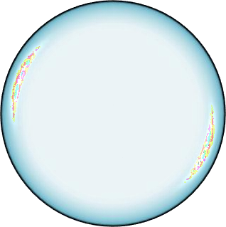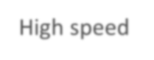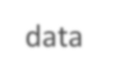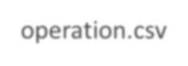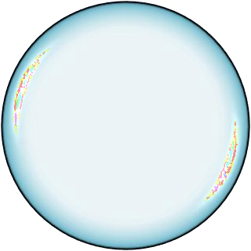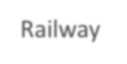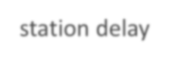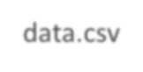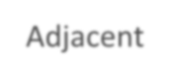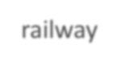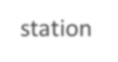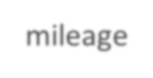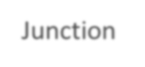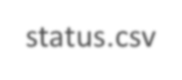

Railway station location

Junction status

Composite train opposite data

Validate data:-